

Institute of Computer

Engineering Technology



iCET Certified Master

ASSIGNMENT

|  |  |
| --- | --- |
| Module | WEB / Enterprise Engineering |
| Batch No | 102 / 103 |
| Lesson | REST API development using Spring Boot |
| Ass. Date | 2023-08-20 |

## Requirement

Develop a two UIs which can perform Student Information registrations and View list of registered Students.

High-level Architecture Diagram

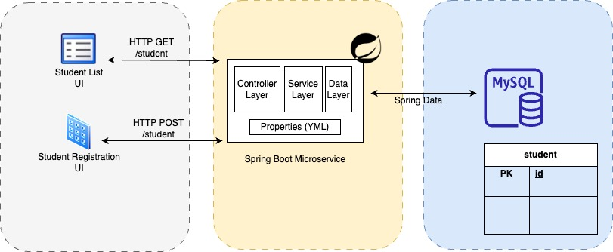

Sample Prototypes

Registration Form Student List View UI

(Sample Only. Design your Own Idea) (Sample Only. Design your Own Idea)

Once Record selected, Profile should show as depicted in prototype (Green box)

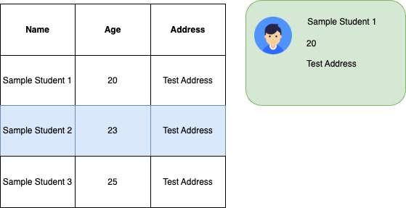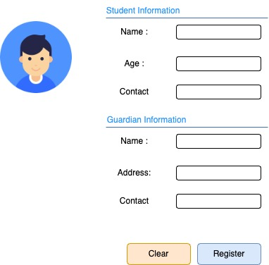

R & D :

Do research on how to store Image on database and send through REST APIs.

Also Rendering using <Img> tag.



Image Base64 encoding and Decoding

## Coursework Instructions

**UI component Instructions**

1. UIs should us below technologies
   1. JS
   2. CSS
   3. HTML
   4. Any Other styling framework (Optional)
2. Decide your own Required Students attributes.
   1. Ex: Student Name / Guarding Information.
3. Use JS Fetch() to consume REST APIs.
4. strictly follow Coding standards / Naming standards and maintainability.

**Microservice Instructions**

1. Develop a Spring based microservice to handle STUDENT Model.
   1. Decide optimal attributes which required to maintain Student information.
2. Microservice should use below technologies.
   1. Spring Boot
   2. Lombok
   3. Spring Data
3. Microservice should have clear cut separation of below Layers.
   1. Controller Layer
   2. Service Layer
   3. Data Layer
   4. DTOs
   5. DAOs
4. strictly follow Coding standards / Naming standards and maintainability.

**Database Instructions**

1. Use MYSQL Community version as your database solution. Version should 8 or above.
2. strictly Naming standards.

## 3.0 Submission

|  |  |
| --- | --- |
| Deliverable Format | .zip file |
| File Naming Convention | [ICM_BATCH _FIRSTNAME_LASTNAME] |
| Submission Date | On or Before 01st of September 2023 |
| Submission Mode | Google Classroom |

**Evaluation points**

|  |  |
| --- | --- |
| Code Quality | 30 % |
| Maintainability | 30 % |
| Out of box thinking | 10 % |
| Completion | 10 % |
| Reusability | 20 % |

**You should score minimum 10% from each Red Color highlighted Mandatory points.